Remedy Acknowledgement

Use Case Document


 | Prepared By / Last Updated By | Reviewed by | Approved By
Name | Harshit Maurya  Deepak Kumar  Sahil Pathak  Priyanka Ganguly  Aastha Pandey | Manoj Kulkarni
Role | Team Member | Team Member | Scrum Master
Signature
Date

Table of Contents
1.0 Introduction 3
1.1 Purpose & Scope of the document 3
1.2 Intended Audience 3
1.3 Use case ‘Remedy Ticket Creation’ 3
1.3.1 Use case attributes 3
1.3.2 Business Rules 4
1.3.3 UI Requirements 4
1.3.4 UI Field Validations 5
1.4 Use case ‘Remedy Connection’ 6
1.4.1 Use case attributes 6
1.4.2 Business Rules 7
1.4.3 UI Requirements 7
1.5 Use case ‘Resource Assignment’ 6
1.5.1 Use case attributes 6
1.5.2 Business Rules 7
1.5.3 UI Requirements 7
1.6 Use case ‘Acknowledgement’ 6
1.6.1 Use case attributes 6
1.6.2 Business Rules 7
1.6.3 UI Requirements 7
2.0 Database Design 8
2.1 Tables Structure 8
3.0 Change Log 10

Introduction

Purpose & Scope of the document
The purpose of this Use case document is to systematically capture requirements for the project and the system to be developed in terms of use cases. Functional use cases are captured in this document. It also serves as the input for the project scoping.

The scope of this document is limited to addressing the use cases from a user, quality, and non-functional perspective.

Intended Audience
Each member of the project team

Use case ‘Remedy Ticket Creation’

Use case attributes
Use Case Description:

This use case deals with the capture of user details. The ‘user’ here shall be the operator of the system and will be keying in the patient information into the system.

Scope:

- User registration

Actors:

- User – the operator

Trigger:

Click ‘Submit’ button in the ‘Book Appointment’ page

Pre-Condition:

User being able to access the homepage & get redirected to the ‘Book Appointment’ page upon click of ‘Fix Appointment’ button

Post Condition:

User is in the enrollment page & submit details

Flow of Events:

User at homepage → Click ‘Fix Appointment’ button → User is in the Book Appointment page → User details are submitted and added onto the database

Primary Scenario:
A new user – is able to click ‘Fix Appointment’ button and able to provide his details and able to submit his details regarding his disease and generate token.

Business Rules

Business rules should be defined using the following attributes: -

- When the user clicks on the fix appointment button, it should re-direct to Fix Appointment form.
    - User needs to fill some of the basic attributes/fields as mentioned below in requirement: Name, Gender, Age, Allergies, Blood Group, Appointment Treatment Type, Email, Contact, Description.
- Clicking ‘Submit’ should validate the datatype constraints for each field
- Post-successful field level validation, save the information in the database
- Upon saving the information in the database, display the message ‘Ticket Created.User query/issue Submitted Successfully’.

UI Requirements
Here is a prototype on how the homepage should look like.
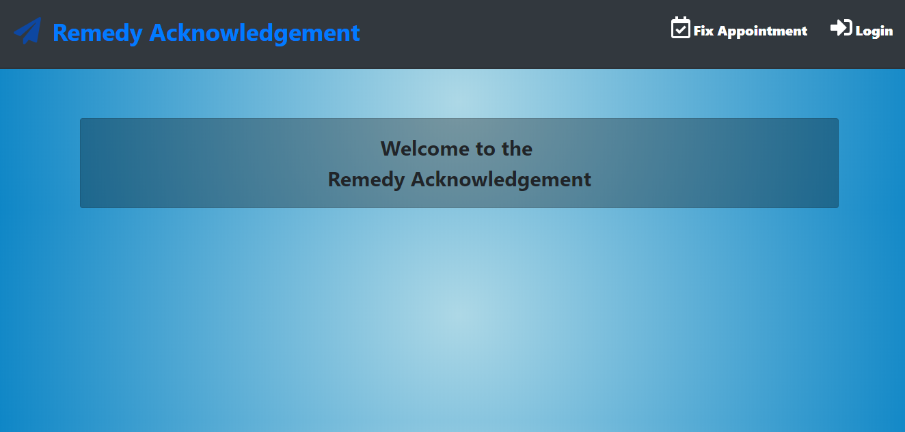

Here is a prototype on how the ‘User Dashboard’ page look like.

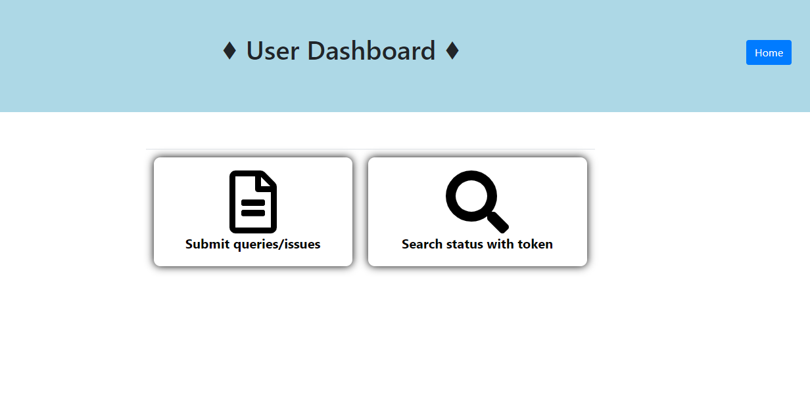
Here is a prototype on how the ‘Book Appointment’ form look like.

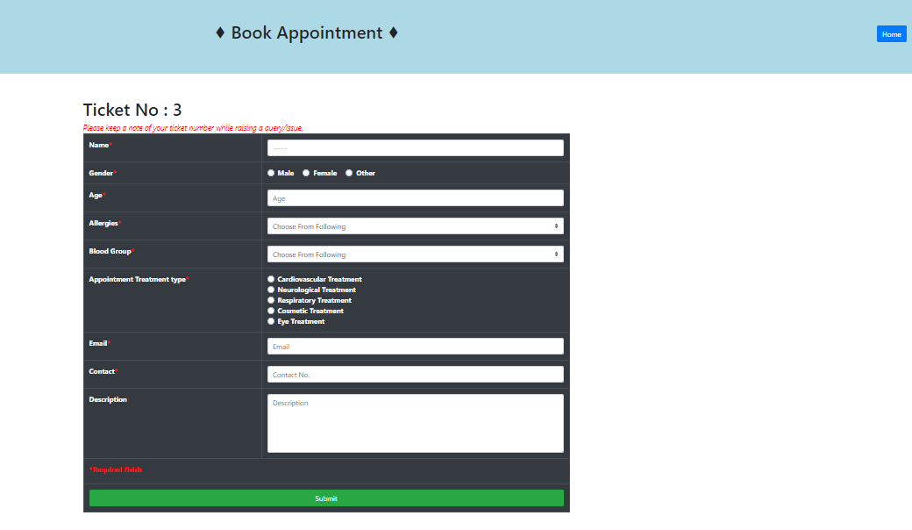

Here is a prototype on how after the appointment is booked, a message is shown look like.

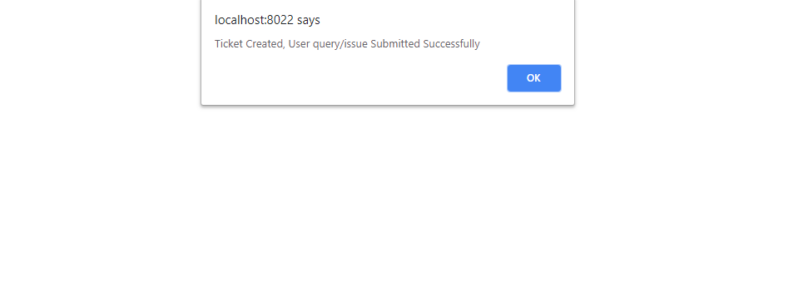

UI Field Validations
Please refer to the below requirements for field level validations:

- All fields except description are mandatory.
- The Email ID format must be checked. (For ex. test@testmail.com.)
- Phone Number must be of 10 digits’ length

Use case ‘Remedy Connection’

Use case attributes
Use Case Description:

This use case deals with the authentication of the user credentials. The ‘admin’ here shall be able to login and open his mailbox and see the form that is filled by the patient and assign the doctor accordingly.

Scope:

- User credentials authentication

Actors:

Admin-The receptionist

Trigger:

Click ‘Login’ link, after keying in ‘Username’ & ‘Password’ field.

Pre-Condition:

Receptionist being able to access the ‘Remedy Acknowledgement’ page.

Post Condition:

Receptionist is in his mailbox.

Flow of Events:

User at Login page→ Key in ‘User ID’ & ‘Password’ field → Admin credentials are validated → Book Appointment page is displayed in the mailbox

Primary Scenario:
A registered user called receptionist– is able click ‘Login’ link, after keying in ‘User ID’ & ‘Password’ field and get his credentials authenticated with the existing database entry.

Alternative Scenario:
A registered user – is able click ‘Login’ link, after keying in ‘User ID’ & ‘Password’ field and unable to get his credentials authenticated. The user is presented with relevant error messages:

- Invalid User ID – ‘Wrong User Name’
- Incorrect Password – ‘Wrong Password’

Business Rules
Business rules should be defined using the following attributes: -

- A registered user – is able click ‘Login’ link, after keying in ‘User ID’ & ‘Password’ field and get his credentials authenticated with the existing database entry.

UI Requirements
Here is a prototype on how the Receptionist Login page should look like.

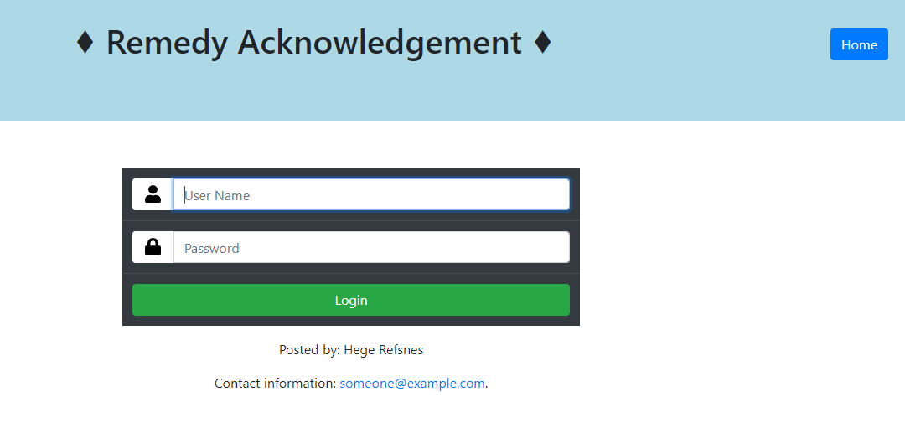

Here is a prototype on how the mailbox that contains the details of the patient look like.

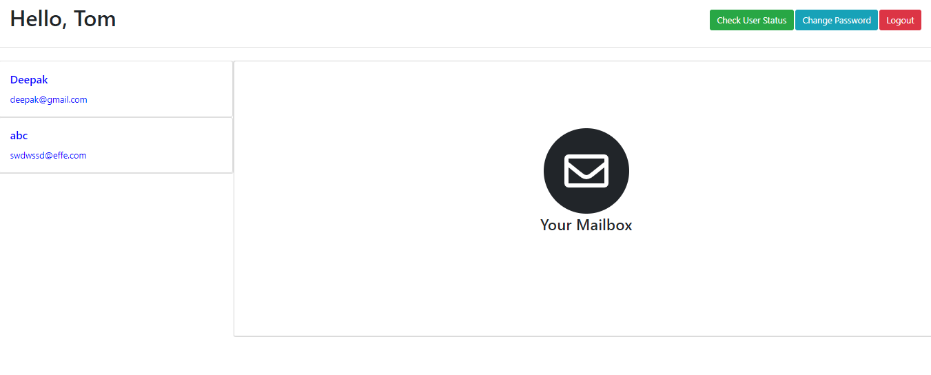

Here is a prototype on how the mailbox that contains the details of the patient look like.

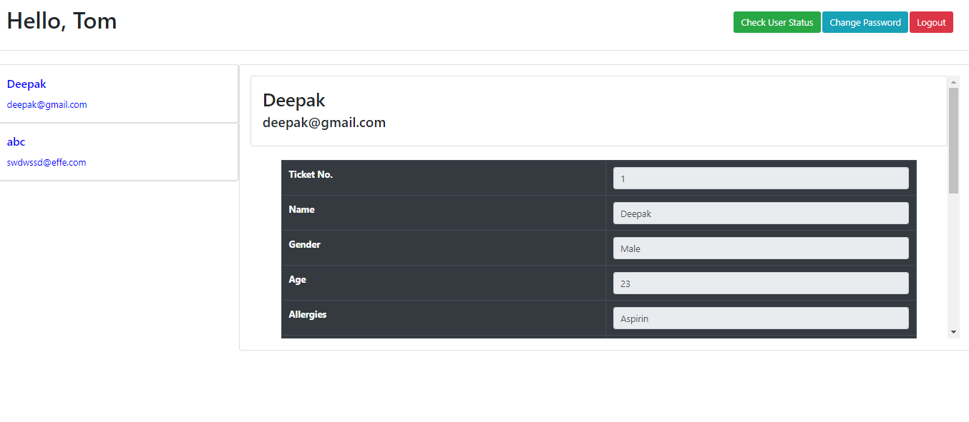

Use case ‘Resource Assignment’

Use case attributes
Use Case Description:

This use case deals with the assignment of the resources to the remedy. The receptionist will assign the doctor that is suitable for the disease.

Scope:

- Resource Assignment

Actors:

- Admin-The receptionist

Trigger:

Click ‘Connect Remedy’ button in the mailbox

Pre-Condition:

Receptionist being able to access the mailbox and able to assign the particular doctor according to the disease to the patient.

Post Condition:

Receptionist is able to assign the resources if available.

Flow of Events:

Receptionist at mailbox->He clicks at ‘Connect Remedy’->Resources are allocated

Primary Scenario:
A receptionist is able to assign the resources to the remedy.

Business Rules

Business rules should be defined using the following attributes: -

- When the user clicks on the mailbox, he should be able to see the ailment of the patient and assign the doctor.
    - Clicking the ‘connect remedy’ should redirect to the ‘connect remedy ‘page.
- Assign the resources if available.

UI Requirements
Here is a prototype on how the connect remedy page should look like.

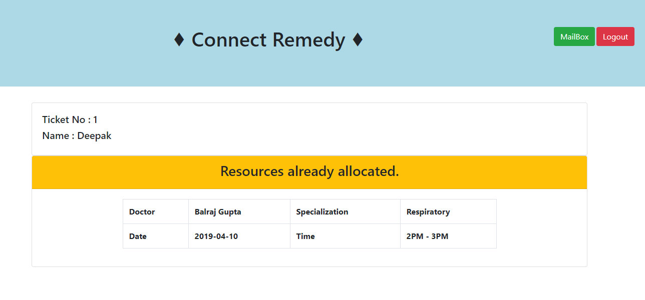

Use case ‘Acknowledgement’

Use case attributes
Use Case Description:

This use case deals with the sending of acknowledgement in the form of token and checking if the resources is assigned or not

Scope:

- Sending Acknowledgement

Actors:

- Admin-The receptionist

Trigger:

Click ‘Check Status’ in the homepage

Pre-Condition:

User being able to access the homepage and check if the doctor for his ailment is assigned to him or not

Post Condition:

User should be able to check if the doctor is assigned to him or not.

Flow of Events:
Click on search status with token->Enter the token and click ‘search’->Status is shown

Business Rules

Business rules should be defined using the following attributes: -

- When the user clicks on the search status with token, he should be able to check his status of the token.
    - Clicking the ‘search’ should show the status of the token

UI Requirements
Here is a prototype on how the User Dashboard should look like.

Here is a prototype on how the ‘Search Status’ should look like.

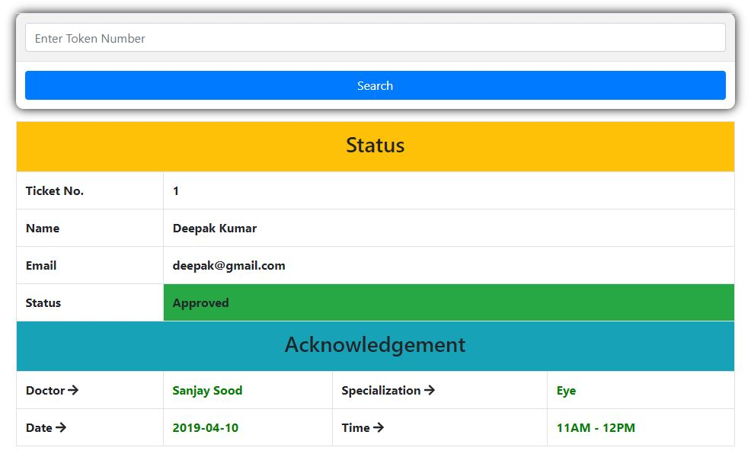

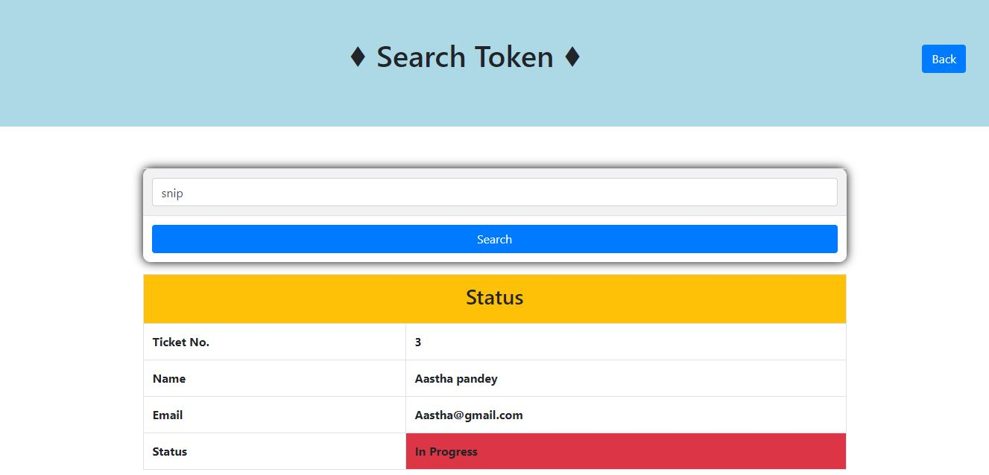

Database Design

Tables Structure
User Registration:
Column Name | Data Type | Length | Nulls
Id | nvarchar | 5 | N
Details | nvarchar | 100 | Y
Status | nvarchar | 20 | Y

User login:
Column Name | Data Type | Length | Nulls
User Id | nvarchar | 20 | N
Password | nvarchar | 20 | N

Change Log
Version Number | Changes Made
V1.0 | Initial baseline created on 19-Mar-2019 by Manoj Kulkarni
V1.1 | <Please refer the configuration control tool / change item status form if the details of changes are maintained separately. If not, the template given below needs to be followed>
V1.1 | Section No. | Changed By | Effective Date | Changes Effected

